**Assignment sheet for IAM**

**Assignment 1 :-** Create an IAM user with username of your own wish and grant administrator policy.

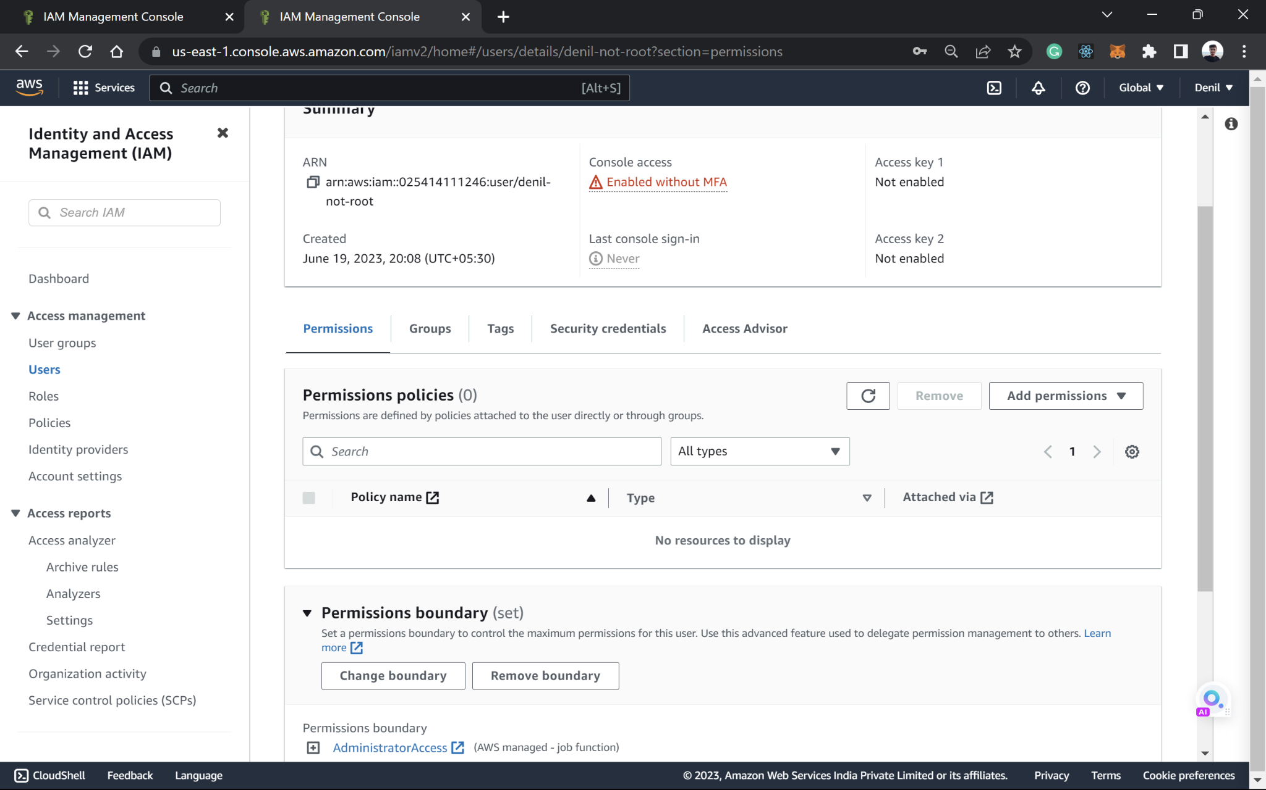

**Assignment 2 :-** Hello students, in this assignment you need to prepare a developers team of avengers. - Create 3 IAM users of avengers and assign them in developer’s groups with IAM policy.

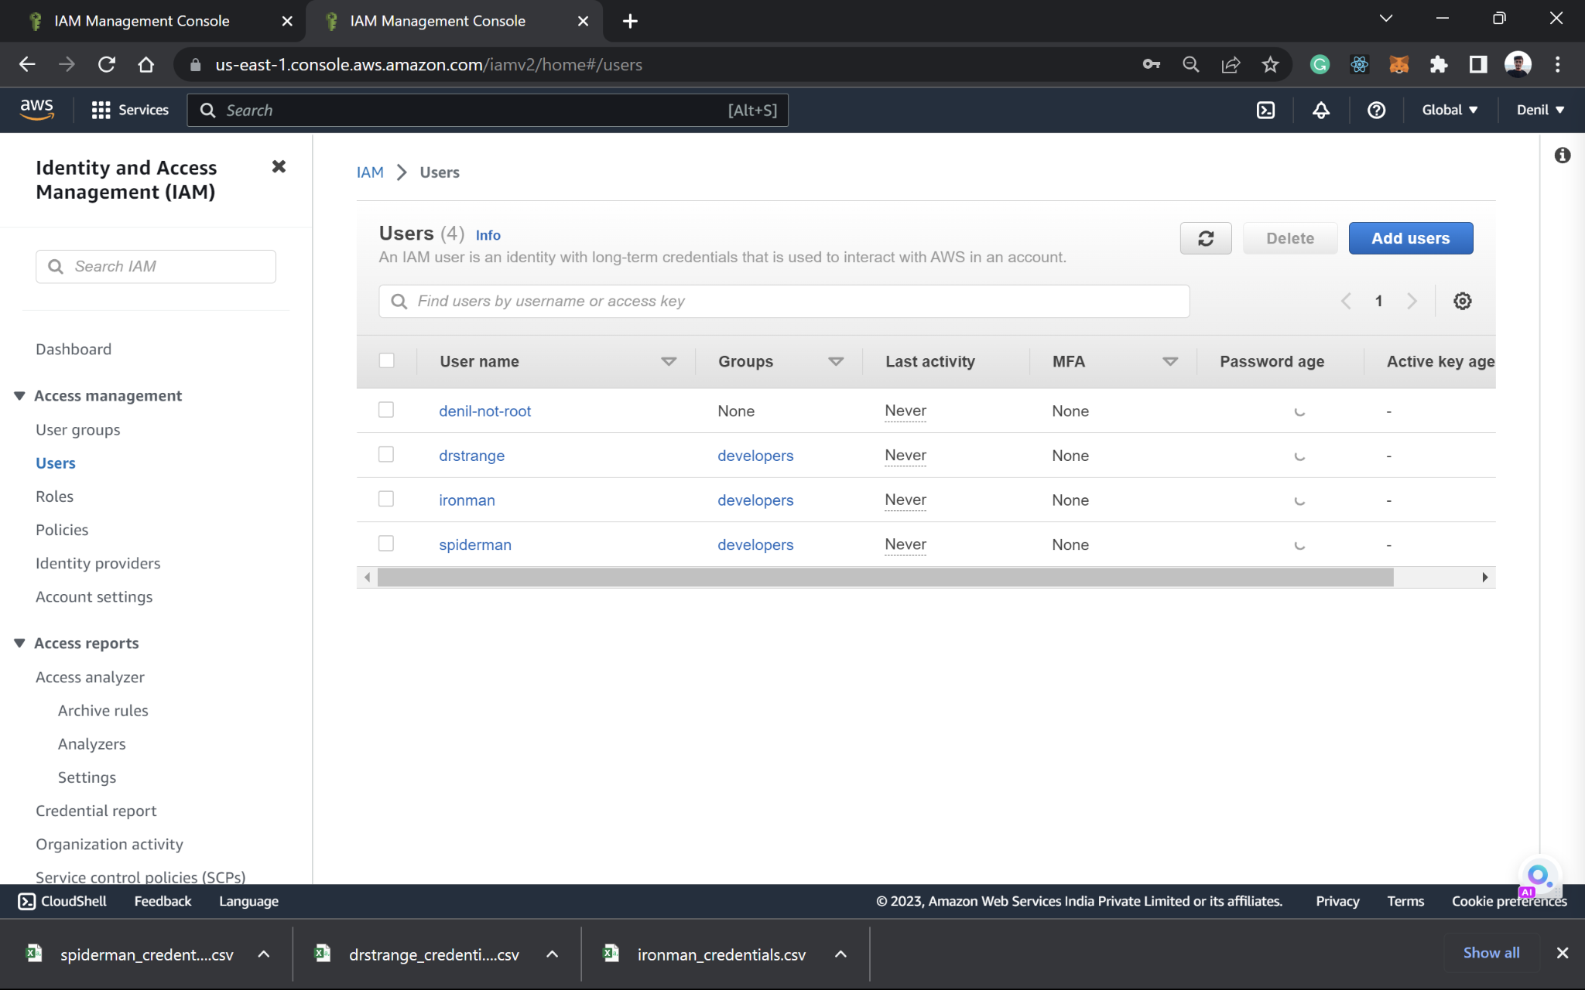

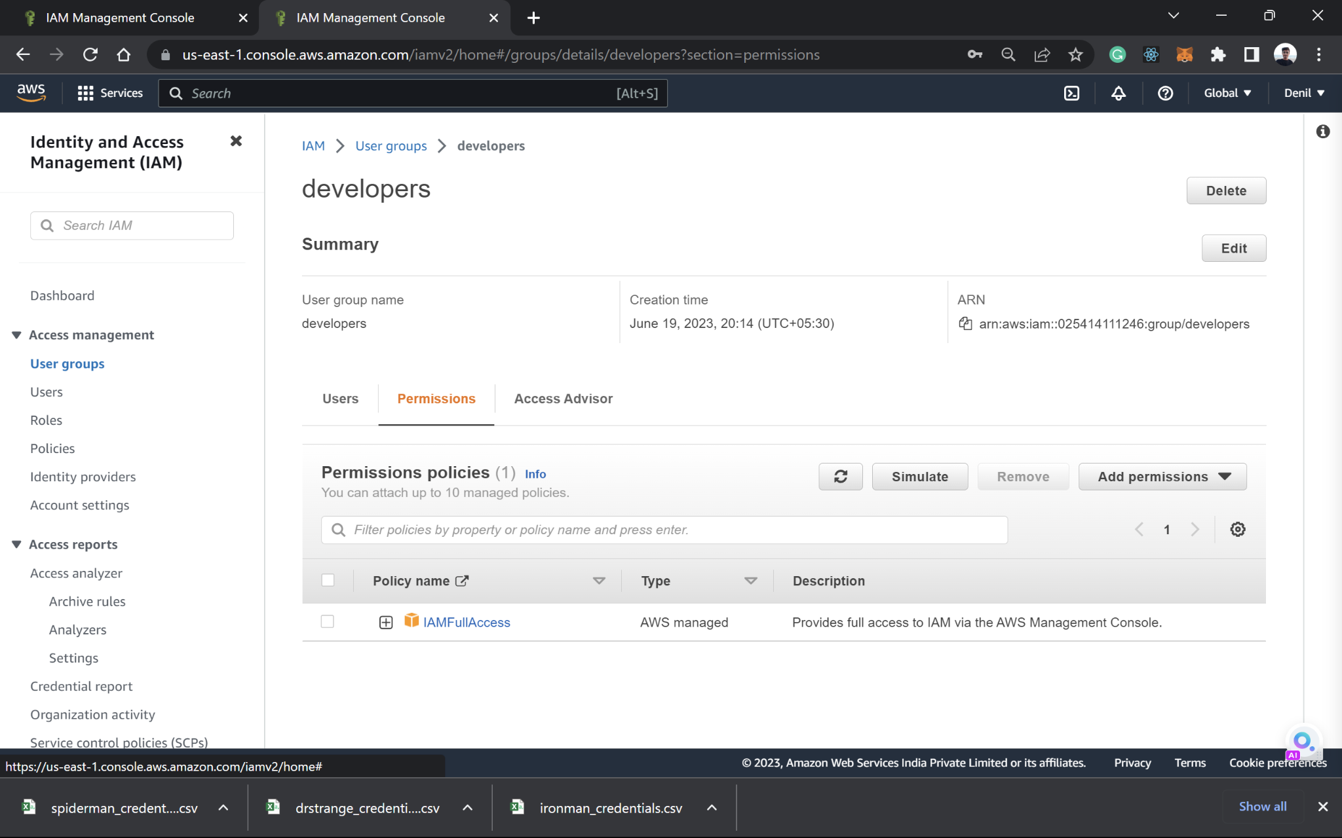

**Assignment 3 :-** Define a condition in policy for expiration like

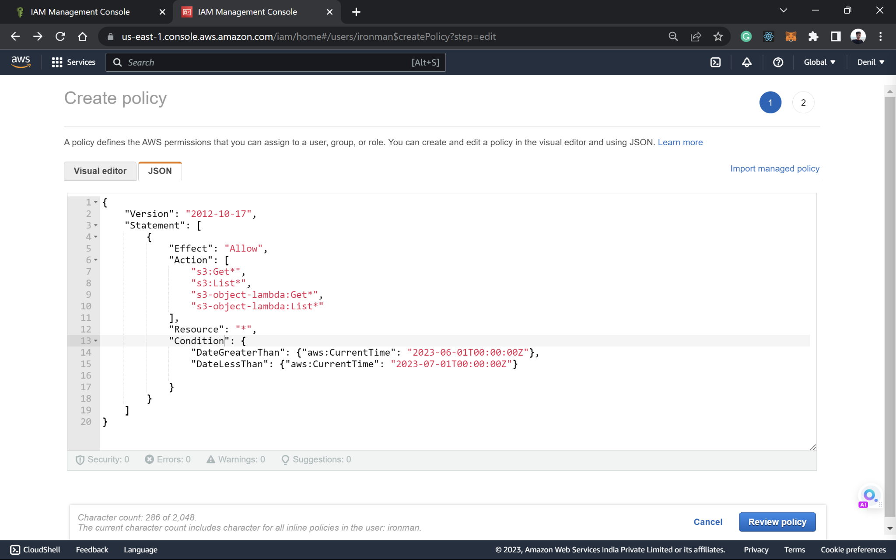

**Assignment 4 :-** Launch your linux instance in IAM and update your machine

